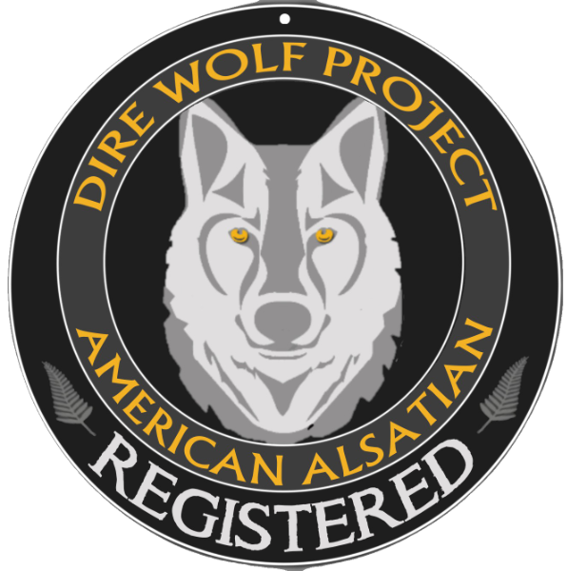
Puppy Health Checklist

NAME OF PUP: WHELPED:
Weight: ________________ Temperature: ____________
TM

 | Normal | Abnormal | Comments
Ears
Clean, free of debris/mites
Eyes
Clear, no cataracts/film
Nose
Clear of mucus
Head
No scars, bites, or scratches
Teeth
no over/under bite
Throat
Clear of debris
Heartbeat
Normal for the size, weight, and age of puppy
Legs
Normally developed for a large breed, including joints
Feet
Without rips/tears, normal number of toes
Tail
Without crooks or damage
Genitals
Anal glands not inflamed or compacted
Coat and Skin
Clean/healthy without fleas or ticks
Stool Sample  Giardia, coccidia, roundworms, other |  |  | Date tested:
Wormed: Puppy Shots:

This puppy was examined thoroughly by a licensed veterinarian from:

______________________________________________ ___________________
Business Name Phone

________________________________________________________ _______________________
Veterinarian Signature Date

